**Full Name: ____________________________**

**Class Exercise Challenge #3**

**GAME 2343/2347 and IMED 1345/2345**

After today’s lecture and hands on activities, you will need to complete the following challenge:

1. Create a new C# script, called it Madlib, in this script, create new variables that you set in the Unity inspector:

A. myName variable type of string.

B. favoriteFood variable type of string.

C. amount variable type of double.

D. likeToShare variable type of bool.

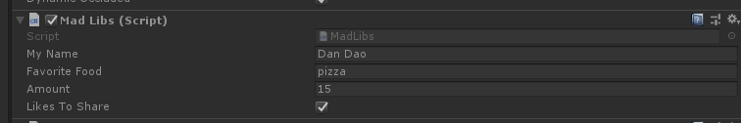

Attached the script to the cube, when on Disable the cube, the console should display, (screen shot below)

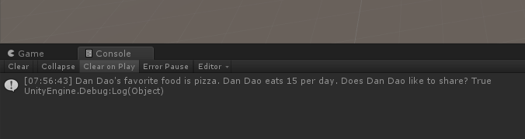

2. Toggle between the two states (checked and unchecked), you will need to take the screen shot, copy and paste it below. Instead of my name, put your name, your favorite food, make up an amount, and enable the Like to Share.

3. Upload this document to eCampus before the due date.